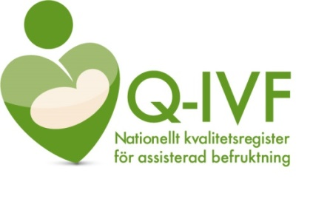
What is Q-IVF?
Since 2007, the IVF clinics in Sweden, with the support of SKR (Swedish Municipalities and Regions), have run a national quality register for assisted reproduction, Q-IVF.
The purpose of the register is to continuously monitor treatment results and any medical risks for both IVF children and treated patients.

You contribute to better care!
The quality register contributes to new knowledge about how we should treat involuntary childlessness more effectively. The information that is recorded is used to compare care between different clinics around the country, to carry out improvement work at the clinics, and for research. Participation in the register is voluntary and does not affect the care you receive. The more people who participate in the register, the more statistically reliable the results become.

Data recorded
Data that is registered are patients' social security number, performed treatments - treatment-related data and their results.

Confidentiality
Your information is covered by confidentiality (Public Access to Information and Secrecy Act). This means that information may only be disclosed from the register if it is clear that neither you nor anyone close to you will suffer harm if the information is disclosed. The data has the same strong protection as medical records.
Your privacy is further protected by the fact that data from the register may only be disclosed for research, quality assurance and statistical purposes. Even in such cases, a confidentiality assessment is always conducted. Before any register data are retrieved for a research study, approval from the ethical review authority is required.

Safety
Those who have electronic access to the data must log in to the register with secure two-step authentication. The security system around the servers where data is stored meets the same rigorous requirements as for the medical records.
All staff have a statutory duty of confidentiality.

Your rights
On Q-IVF’s website under "For patients" you can find SKR’s patient information about quality registers, which describes your rights in more detail. Participation is voluntary. If you do not wish to participate, you must notify your clinic. It is possible to do this verbally; however, for safety and traceability, we prefer that you fill out a written "Opt-out form" that is available through your clinic. It is also available on Q-IVF's website. If you wish to have previously recorded data deleted from the register, this must be done in writing.

More information
On the website, www.qivf.se, you will find contact information for the registry as well as annual reports with treatment results, patient-perceived quality of care, open comparisons between clinics, etc.

Head of the registry
Evangelia Elenis
Associate Professor/Senior Consultant
Reproduction Center Uppsala University Hospital Uppsala

